Bangkok
Bangkok is the capital , largest city of Thailand . That meaning " city of angles ", The population of Bangkok is close to 9 million people. it was originally a small trading post on the west bank of lower Chao Phrayr River during the Ayuttaya kingdom . it become the capital in 1768 .
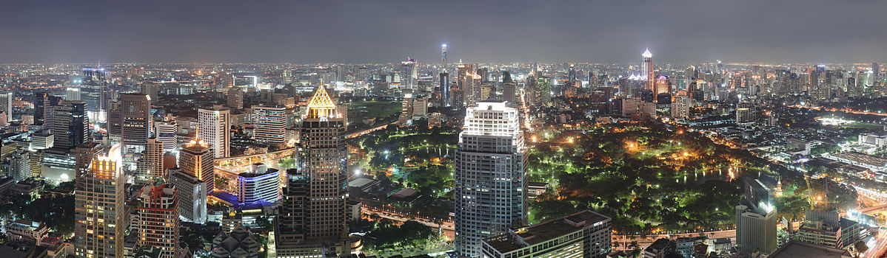
Climate : Bangkok has a tropical wet and dry climate . The most beautiful time for visit from Desember to April . the rainy season is from May to November.
Visiting Bagkok : Bangkok is the fashion and entertainment city . it was the second most expensive city in Sauth – East Asia behind singapora . The city has excellent and modern puplic transport systems . The skytrain and underground rail systems connect the main shopping , entertainment and business areas of the city . Tuk-tuke once a big Bangkok attraction . They are slowly of more comfortable transport , but are still worth a ride at least once .The People are very Friendly , but it difficult to understand them becouse they don't speak English well .

Renad Turki Ezzat

